HTML Task
You have to use HTML Only You are not allowed to use CSS to implement the images below:
- Create a repo on your GitHub account (HTML Task)
- Clone this repo on your local machine
- Open it using vs code
- Create different HTML pages for each step.
Update the readme file with the following:
- What is this task?
- Push your work
- Submit the repo link.
1. Form page
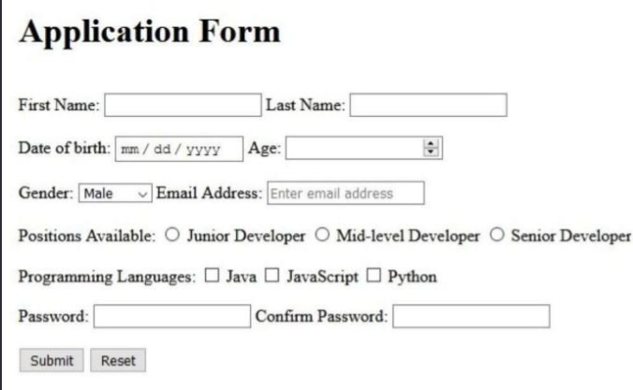

2. List page
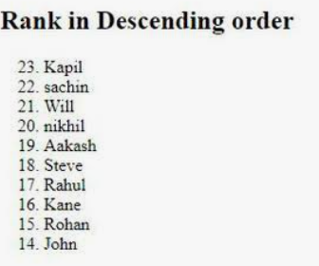
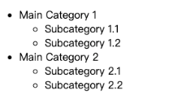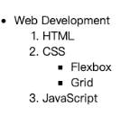
3. Table page
